Westward Expansion After the Civil War

Economic Development:
Agricultural:
Cattle: need for beef in eastern __________ and western ___________ towns
Corn and wheat: _________ ___________ allows Great Plains to be farmed
Industrial:
Mining: California, Sierra ______________, Black ______________
__________ ___________: 1859 largest silver strike in world (Nevada)
__________ __________: quick settlements established in areas where gold and silver were found
Tent cities like _____________City, Nevada led to wooden frame towns bustling with economic growth as long the ore was being mined
Climates: limited settlements due to harshness of climate
- Great American Desert (_____________ _______________) – sod to thick to farm
- ________________ Mountains – mining boom towns
Markets and Trade:
__________________ follow the miners
Tailors, restaurant owners, hotels, laundry
Railroads offer land to settlers to create bigger markets
Label Map: p. 576, 580, 591 Chisholm Trail, Goodnight-Loving Trail, Omaha, Cattle,
Union Pacific, Central Pacific, Promontory Point, Corn, Mining, Wheat, Abilene, Sacramento
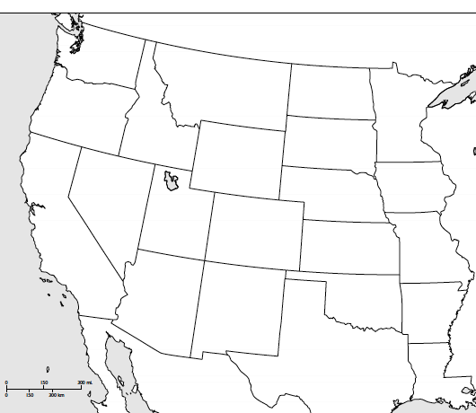
Federal Policies Toward Native Americans: US gov’t _____________ to safeguard Great Plains Indians lands, but as miners and railroads moved in, treaties were ________________
Movement to __________________: US set aside land for the Native Americans to live on
________ ________ Treaty 1851: US wanted the Native Americans to stop following the_________ and settle permanently. If they do that the US would protect their land forever. Treaty broken by US in 1859 with ___________discovered in Colorado.
Assimilation: attempts by the US gov’t to change the __________ ____________ lifestyle and make them “American”
Boarding Schools: (__________Act) Reformers believed through proper education and treatment, Native Americans could become just like other citizens
Carlisle Indian School, PA 1879 1st Boarding School
Native American children lived at schools with little contact from family
Wars with Indians:
Little Big Horn: gold was discovered in 1874 in the _________ __________
Sioux and Cheyenne led by _______ _______ and _________ ________ led attacks to keep whites out
US Army led by General _________ ________ led attack in Little Bighorn Valley, MT
All US soldiers were ____________
Wounded Knee: 1880’s Native American movement involving the _________ _______ led them to believe the buffalo and their ancestors would return and the whites would leave
Dec 1890 police tried to stop the dance and arrest ________ ________ and he was killed
A band of Sioux tried to avoid more violence by leaving and were surrounded by the US army at Wounded Knee Creek, South Dakota
As the Nat. Amer.s were handing over their ________, shots were fired and ________ Sioux men, women, and children were killed
This event ended the era of ___________ __________ in US history
Impact of Railroads and Pioneer Settlement Patterns:
Massive increase in settlers, land given to railroad companies by gov’t hemmed in Nat. Amer
Led to _________________
Buffalo Soldiers: ____________ _____________ soldiers from the Civil War who fought the __________ ____________and captured _______________in the Great Plains for 20 years (1860’s). Made famous by their buffalo hide clothing and named by Native Americans for their _______________
George Jordan: former _____________ ________ who received the _________ __ ___________ for fighting the Native Americans in the West
Dawes Acts: 1887 US attempt to stop Native American’s wandering and encouraged _______________
Each male received ___________acres
Boarding Schools built to change their _____________
Program ____________, Nat. Amer. Sold their land and became ____________ of the US gov’t for food
Primary Source: “Century of Dishonor”

Significance of Famous American Indian Leaders: Resisted white expansion and life on reservations
Crazy Horse: Lakota Sioux Indian chief who led a war party to victory over General Custer at the Battle of ___________ ________ _______ in an effort to stop white expansion onto his lands. Killed 4 years later after he _____________ by US army soldier.
__________________: Fierce Apache warrior who resisted living on a reservation and attacked settlers in Arizona and New Mexico for 10 years before being capture in 1886 and sent to a reservation in Oklahoma
___________ _________: Lakota Sioux holy man who resisted white expansion and was a leader at the Battle of Little Big Horn. Killed after _________________ years later
Chief Joseph: ________ ________ leader whose people were forced to move to reservation. He revisited and fled to ____________. US army caught him and he said, “I shall__________ no more forever.”

Impact of Homestead Act: 1862 US gov’t offered ________ ________ to anyone that would live there for ___ years
Congress gives the poor a chance to own farms
__________________ – settlers who acquired free land from the gov’t on the Great Plains
Problems: Few had money to move there, plots too____________, land companies took over area __________, ______ in 3 homesteaders lasted 5 years

Significant Inventors and their Inventions:
____________ ____________: 1874 Joseph Glidden invented this new type of fence due to the lack of wood on the plains to keep cattle off crops
_________ _________: 1836 Samuel Colt created the revolver (small, easy to carry, easy to reload, accurate), called the Peacemaker
______________: used to pump water to the surface from wells hundreds of feet deep to water crops and cattle
__________________: Sod is thick top layer of soil and matted roots in the plains that hardened in the sun
Settlers cut sod bricks to build their homes
_______ Plow: 1837 _______________ invention allowed farmers to cut through the________ and plant crops

Transcontinental Railroad: US gov’t gave land subsidies of 10 square miles of land around each mile of track they laid. 1862 Central Pacific RR began in _________________, CA heading east and Union Pacific RR began in _________, NE heading west
____________ ____________ Event 1869: the 2 RR’s met at Promontory Point, Utah (the USA’s coast are now connected)
________ Immigrants: Central Pacific brought 100,000 Chinese to build the RR (low pay, dangerous, Indians)
____________ Immigrants: Union Pacific hired Irish immigrants (low pay)

Cowboy Life: ranching began in Mexico and Spanish and Mexican vaqueros, cowboys, taught many American cowhands cattle herding. __________ of all cowhands in the west where Mexicans
Skills: kept herds together, crossed ________, fought________ fires, chased of ____________, pulled animals from __________________
Clothes: ____________ to protect legs, broad brimmed hats, lassos
Daily Life/Work: 18 hours a day in the saddle for $______ a day

American Ranching Industry: herds grew from strays lost by ______________ ranchers
____________ ____________: unfenced land cattle wandered on eating prairie grass
_______ _______: In Spring, cowhands would begin a cattle drive to rail lines north over _______ miles away
During the 2-3 month journey, the cattle would be fattened up before going to the slaughterhouses
_________ __________: settlements at the end of a cattle trail
1867 Joseph McCoy founded ___________, KS where cowboys could get a bath, good meal, soft bed, and entertainment while their herds of cattle wait to be shipped

