Unit 5 War of 1812- Monroe Doctrine
War of 1812 (_________-________)(_______________ vs. ______________)

Causes of the War of 1812:
1. U.S. tension with Native Americans was growing (late 1700’s and early 1800’s)
A. Britain was backing and supporting the ________________________ in the west.

B. Shawnee chief ____________________ created an alliance with tribes in the west in order to fight the U.S. settlers coming in large numbers.
* (1811) the governor of the Indian Territory, ______________________________, decided to take action against Tecumseh and hit alliance.
* U.S. forces, under Governor Harrison, won the decisive battle against Tecumseh at the __________________________. This broke Indian power in the area.

2. British policy of ______________________- capturing and forcing men into military service.
A. War between Britain and France (1803-1815 part of the Napoleonic Wars) caused each country to try and cut off the other country’s foreign trade.
* Both sides started seizing U.S. ships, mostly U.S. merchant ships
- Between 1803-1807 France seized 500 U.S. ships & Britain seized over 1,000
- Most famous incident: HMS Leopard attacked USS Chesapeake taking 4 crewmembers

* Britain desperately needed sailors for their navy, especially with their war with France, so they seized & forced 1,000’s of American sailors into the British navy. In fact this was British policy all over the world.

B. The U.S. response to the British & French actions was to cut off trade with both countries.
* Act (1807) and the Act (1809) are examples
* Note: Neither of these acts worked. Both actually hurt the U.S. economy
* However these did push America to increase domestic industrialization instead of relying on foreign manufacturing, which helped us later on.

3. _____________________________-Americans who pushed for war with Britain.
* They felt our national pride was at stake.
* 2 major War Hawks: 1. _____________ (KY Rep.) 2. ___________________ (S.C. Rep)
* Most of the opposition for war was from New England merchants who felt that war with Britain would hurt the American economy.

War of 1812 Starts (_____________________________ was President at the time)
* British naval importance throughout the war was to ________________________________.
* American troops tried to invade ____________________ but were unsuccessful.
* American forces were able to win a major victory on __________________

* ________________________________ of TN, was an important U.S. General during the war.
- General Jackson and his men won a major victory over the Creeks at the
__________________________________. The treaty ending this “Creek War” forced the Creeks to give up millions of acres of land to the U.S.
* Britain’s strategy changed in 1814. They went on more of an attack.
- Britain’s fight with France was basically over allowing more troops to come fight in America.
- Britain attacked the nation’s capital ________________________________ burning several key government buildings, including the __________________________.
- After burning Washington, Britain turned towards Baltimore.

* Fort (September 13-14, 1814) This fort protects Baltimore harbor.
- Britain warships bombarded the fort all night long but they could not take the fort. The next day a larger U.S. flag was flown over the fort.
- American ______________________________ happened to be watching the battle and the next morning he saw the U.S. flag still flying and wrote a poem on the back of an envelope. This poem was “__________________________________________”.
* This poem was eventually set to music and in 1931 Congress made it our ________________________________.

End of the War
* Britain and the U.S. sign the _____________________ on December 24, 1814 ending the war.
- It took several weeks before word of the treaty reached many back in the U.S. and it wasn’t ratified until Feb. 1815.
- What did the treaty do for both countries?

*______________________ was the last major battle of the war. It took place on Jan. 8, 1815.
- General ____________________ & his men won a stunning victory over the British at the Battle of New Orleans. A U.S. force of 4,800 defeated a British force of 11,000.
- The large number of Tennessee militia fought with General Jackson at this battle, thus giving the state of Tennessee its nickname the ______________________ state.
Jackson's army of 4,732 men comprised 968 US Army regulars, 58 US Marines, 106 seamen of the US Naval battalion, 1,060 Louisiana Militia and volunteers (including 462 freedmen), 1,352 Tennessee Militia, 986 Kentucky Militia, 150 Mississippi Militia and 52 Choctaw warriors, along with a force of the pirate Jean Lafitte.
* Note: Andrew Jackson & William Henry Harrison ride their fame to being 7th & 9th President

Consequences (Effects) of the War of 1812
1. Increased _____________________________________

2. Rise in American _________________________________.

3. Broke the power of _________________________________________ east of the Mississippi River

4. Increased America’s political standing in _________________________

Henry Clay
* He developed an economic plan called the ________________________________.
- He proposed that ________________________ benefitted all regions of the country.
- He felt the tariffs would provide much needed revenue for the government.
- The money raised by the tariffs could build up _________, __________ and __________.
- He felt a _____________________ would increase commerce & a national currency.
- His plan was not fully implemented but it did get support for building up the nation’s infrastructure, especially in the South and West.
Missouri Compromise
(__________________________ proposed this in 1820)
* Key Points Missouri Compromise: This plan hoped to avoid conflicts over slavery
1. __________________ would enter the Union as a “free” state
2. __________________ would enter the Union as a “slave” state
3. The free/slave state border for new states would now be at the ______________.

Convention of 1818 (Treaty of 1818)
This agreement established part of the present-day border between the United States and Canada. The agreement stipulated that 49 degrees north latitude (__________________) would mark the boundary, from the Lake of the Woods west to the Rocky Mountains. Eventually the 49th parallel border would extend to the Pacific Ocean.

Adams–Onís Treaty (1819)
This was a treaty between the United States and Spain in 1819 that ceded __________________ to the U.S. and defined the boundary between the U.S. and New Spain.

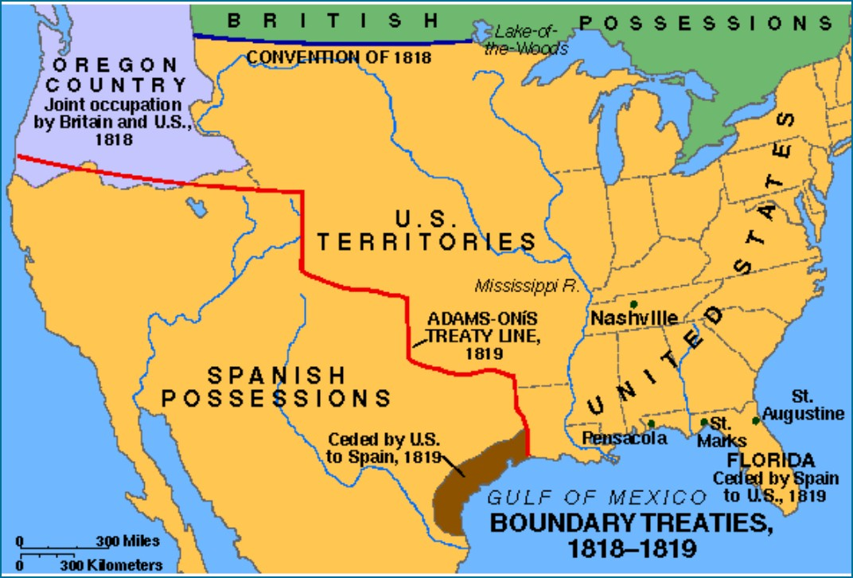

Monroe Doctrine (1823)
*Latin American countries started declaring independence from Spain.
__________________________ feared that European countries would try to take control of the newly free Latin American countries, or help Spain regain them.
He was also worried about ___________________________ in the Pacific Northwest.
* Britain wanted to issue a joint statement with the United States but we refused.
3 Key Points Monroe Doctrine:
1. The U.S. would stay out of European affairs in the _______________________________.
2. U.S. would not allow European countries to create new colonies in America, nor interfere with any of the new Latin American countries. Any European interference in the Western Hemisphere would be considered an _____________.
3. European countries could keep any current colonies or territories in America

